Google Cloud

# Google Compute Engine (GCE)

## [Compute](https://cloud.google.com/compute/)

* Zonal
* Fast booting Virtual Machine (VMs) you can rent, on demand
* Infrastructure-as-a-Service (IaaS)
* Machine Type
  + Standard
  + High Memory
  + High CPU
  + Custom CPU/RAM
* Pay by the seconds (60 seconds min) for CPU’s, RAM
* Automatically cheaper if you keep running it (“sustained use discount”)
* Even cheaper for preemptible or long-term use commitment in a region.

## [Google Kubernetes Engine](https://cloud.google.com/kubernetes-engine/)

* Regional
* Managed Kubernetes cluster for running Docker containers (with autoscaling).
* Used to be “Google Container Engine” but still GKE until Nov 2017.
* Kubernetes DNS on by default for service discovery.
* No IAM integration.
* Integrates with Persistent disk automatically.
* Pay for underlying GCE instances
  + Production cluster should have 3+ nodes.

## [Google App Engine](https://cloud.google.com/appengine/)

* Regional
* Platform as a Service (PaaS) that takes your code and runs it.
* Much more than just compute – Integrates storage, queues, NoSQL etc.
* Flex mode (“App Engine Flex”) can run any container and access VPC.
* Auto scales based on load even scale to zero if no load

## [Google Cloud Functions (GCF)](https://cloud.google.com/functions/)

* Runs code in response to events.
* Function as a Service (FaaS), “Serverless” – Similar to AWS Lamda
* Pay for CPU and RAM assigned to function, per 100 ms (min 100ms)
* Each function automatically gets an HTTP endpoint.
* Can be triggered by GCS objects, Pub/Sub messages etc.
* Massively scalable (horizontally) – runs many copies when needed.
* Often used for chatbots, message processors, IoT, automations etc.

# Storage

## [Local SSD](https://cloud.google.com/compute/docs/disks/#localssds)

* Zonal
* Very fast 375GB solid state drives physically attached to server.
* Can stripe across eight of them (3TB) for even better performance.
* DATA WILL BE LOST whenever the instances shut down.
  + But can survive a long migration.
* Always encrypted at rest.

## [Persistent disk](https://cloud.google.com/persistent-disk/) (PD) – Amazon EBS

* Flexible block-based network -attached storage; boot disk for every GCS instance.
* Performance scales with volume size; max way below Local SSD, but still plenty fast.
* Persistent disk persists and are replicated (zone or region) for durability.
* Can resize while in use (upto 64 TB), but need file system update within VM.
* Snapshots adds more flexibility and capability.
* Not file -based NAS, but can mount to multiple instances if all are read-only.

## [Cloud Firestore](https://cloud.google.com/filestore/) – Amazon EFS

* Fully managed file-based storage.
* Accessible to GCE and GKE through private VPC, via NFSv3 protocol.
* Primary use case is application migration to GCP
* Fully manages file serving, but not backups.
* Pay for provisions TB’s slow or premium.

## [Google Cloud Storage GCS](https://cloud.google.com/storage/) – Amazon S3

* Regional or Multi-regional.
* Infinitely scalable, fully managed, versioned, and highly-durable object storage.
* Designed for 99.99999999999 (eleven 9’s) durability.
* Strongly consistent.
* Integrated site hosting and CDN functionality.
* Lifecycle transitions across classes:
  + Multi-regional
  + Regional
  + Nearline
  + Coldline
* All classes have same API, so you can use gsutil

# DATABASES

## Cloud SQL – Amazon RDS

* Regional
* Fully managed and reliable MySQL and PostgreSQL databases.
* Supports automatic backup, replication and failure etc.
* Scaling is manual both vertical and horizontal
* Effectively pay for underlying GCE instances and PD’s.

## Cloud Spanner

* Regional, multi-regional or global.
* The first horizontal scalable, strongly consistent, relational database service.
* Chooses consistency and Partition-tolerance (CP of CAP Theorem)
* But still high availability, SLA is 99.999% and SLO is 99.99999%
* Pay for provisioned node time plus used storage-time. Very highly expensive

## BIG Query (BQ)

* Multi-regional
* Serverless common-store data warehouse for analytics using SQL.
* Scales internally (TB in seconds and PB in minutes)
* Pay for GB’s actually scanned during queries.
* Attempted to reuse cached results which is free.
* Pay for data stored GB’s/month
* Pay for streaming data

## BIG TABLE

* Zonal
* Low latency and high throughput NoSQL DB for large operational and analytics app.
* Supports open source HBase API.
* Integrates with Hadoop, Dataflow and Dataproc.
* Scales seamlessly and unlimited.
  + Storage autoscales
  + Processing nodes needs to be scaled manually.
* Pay for processing node hours and GB-hours for storage

## Cloud Datastore

* Regional and multi-regional.
* Managed and auto scaled NoSQL DB with indexes, queries and ACID trans support.
* Queries are complicated due to NoSQL
  + No joins or aggregates must line up with indexes.
  + NOT, OR, and NOT EQUALS (<>, !=) operations not natively supported
* Automatic built-in indexing for simple filtering and sorting.
* Manual composite indexes for more complicated, but beware them exploding.

## Firebase Realtime DB & Cloud Firestore

* No SQL document stores with ~real time client updates via managed websockets.
* Firebase DB is single JSON doc located in central US.

# DATA TRANSFERS

## DATA Transfer Appliance

* Rackable, high capacity storage server to physically ship data to GCS.
* Ingest only.
* 100 TB or 480 TB versions.

## Storage Transfer Service

* Destination is always GCS bucket.
* Source can be S3, HTTP/HTTPs endpoint.
* One time or scheduling transfers.
* Free to use, but pay for its action.

# External Networking

<Details pending>

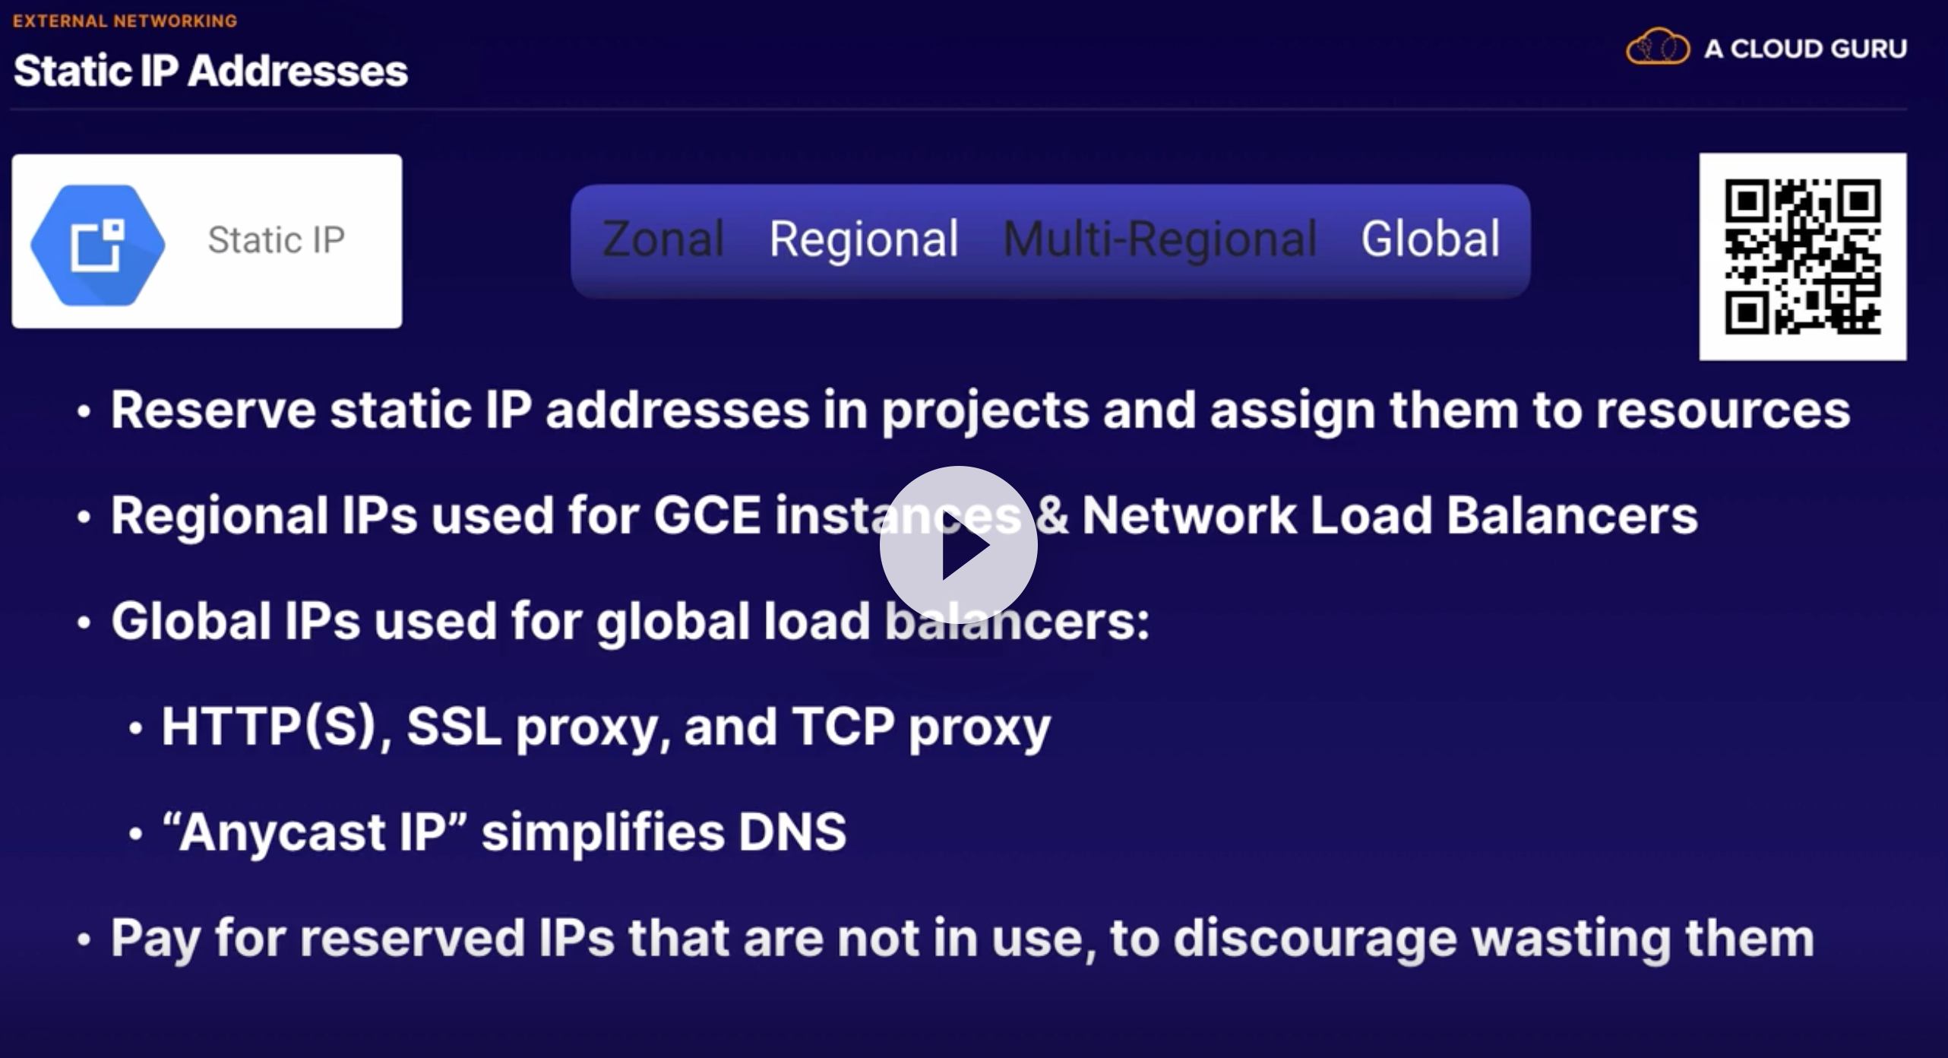

# INTERNAL NETWORKING

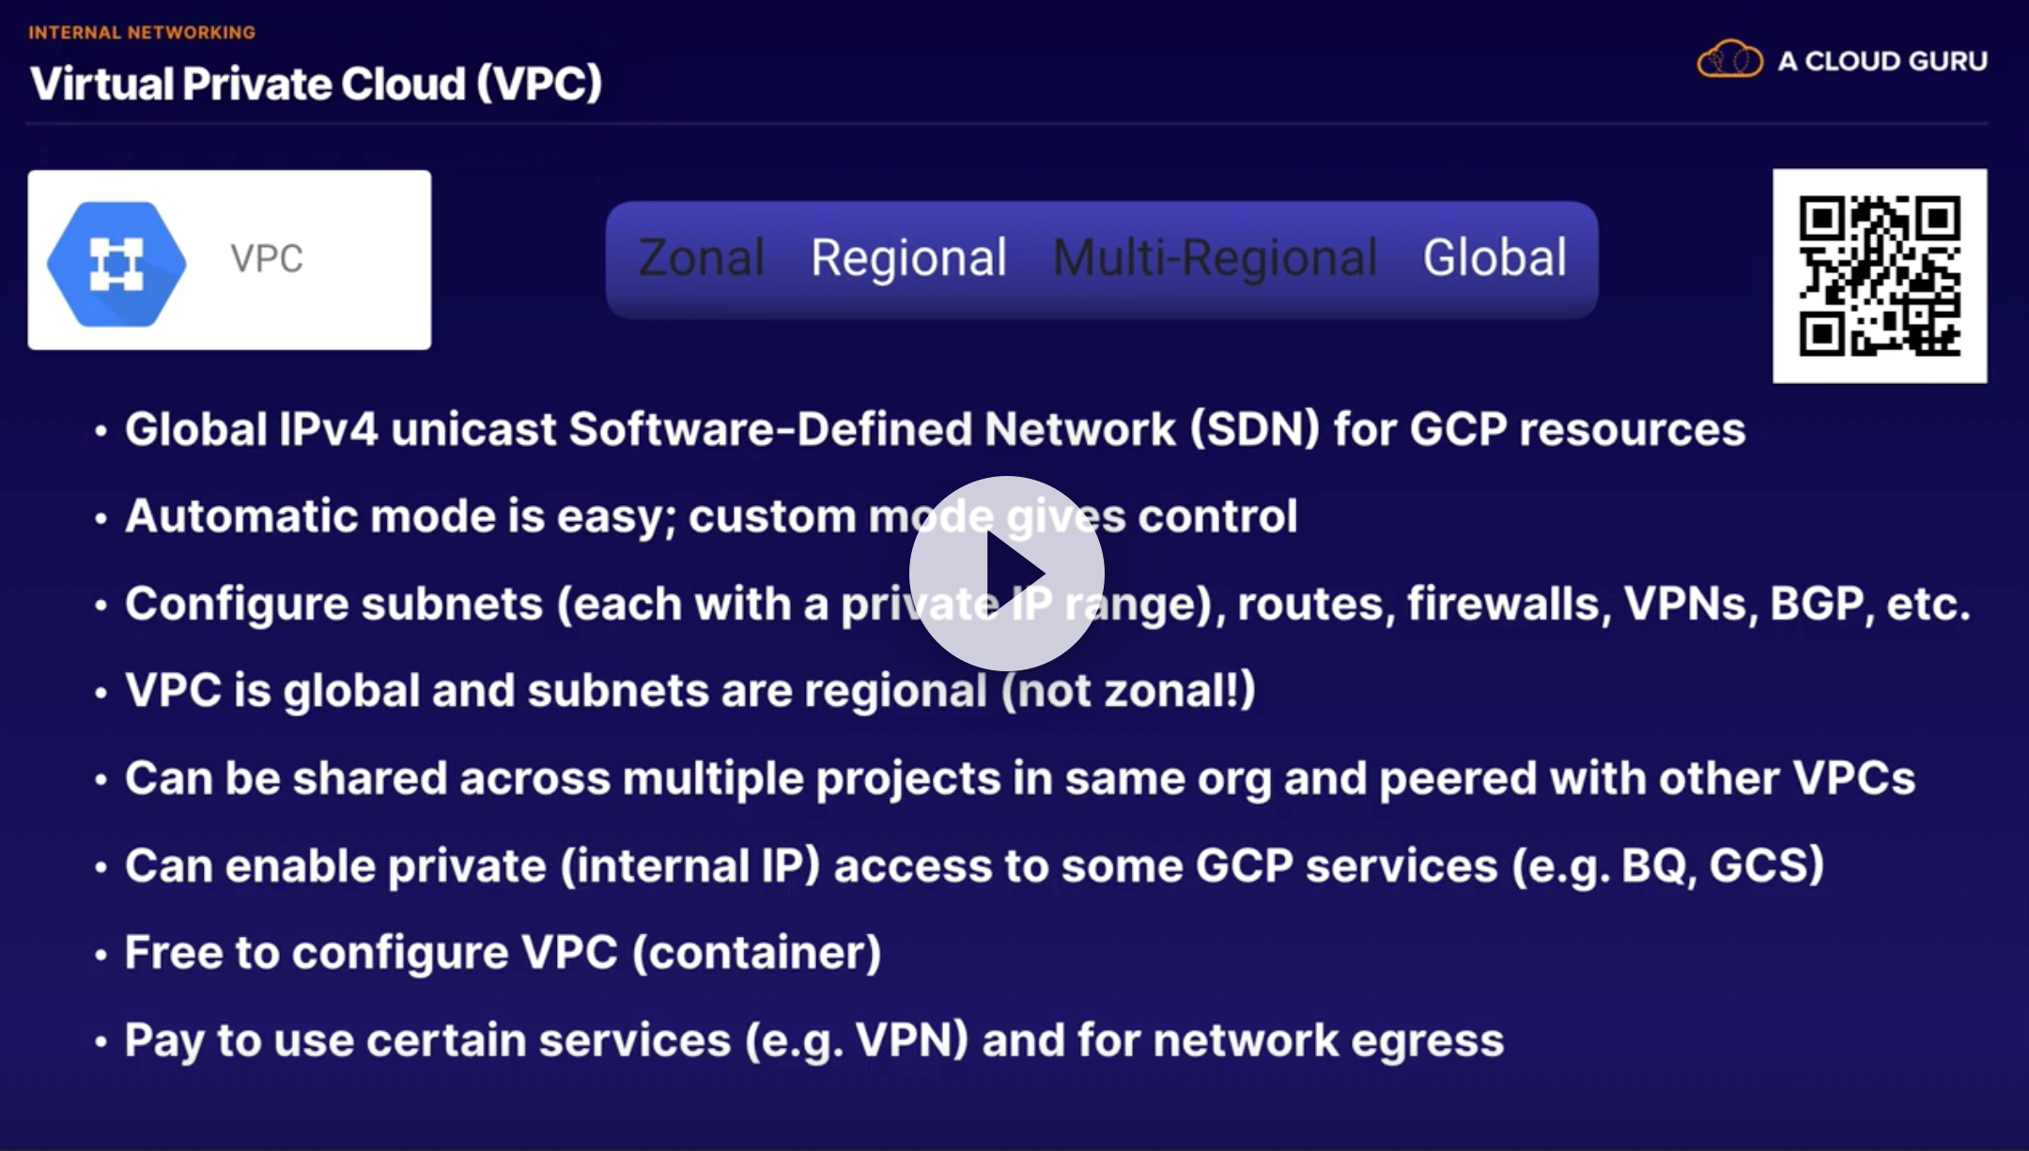

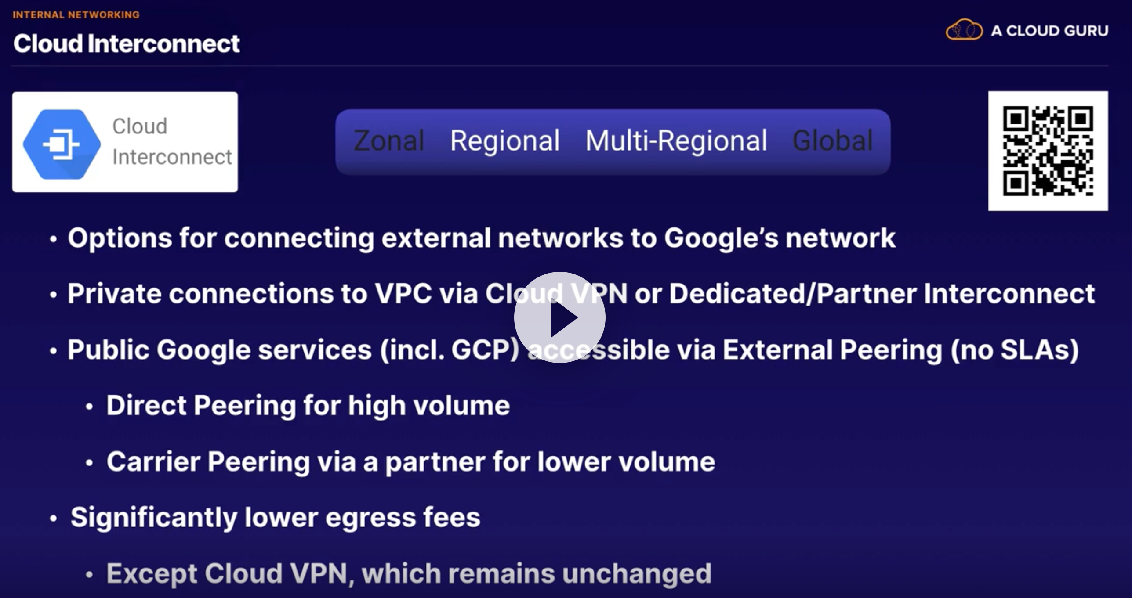

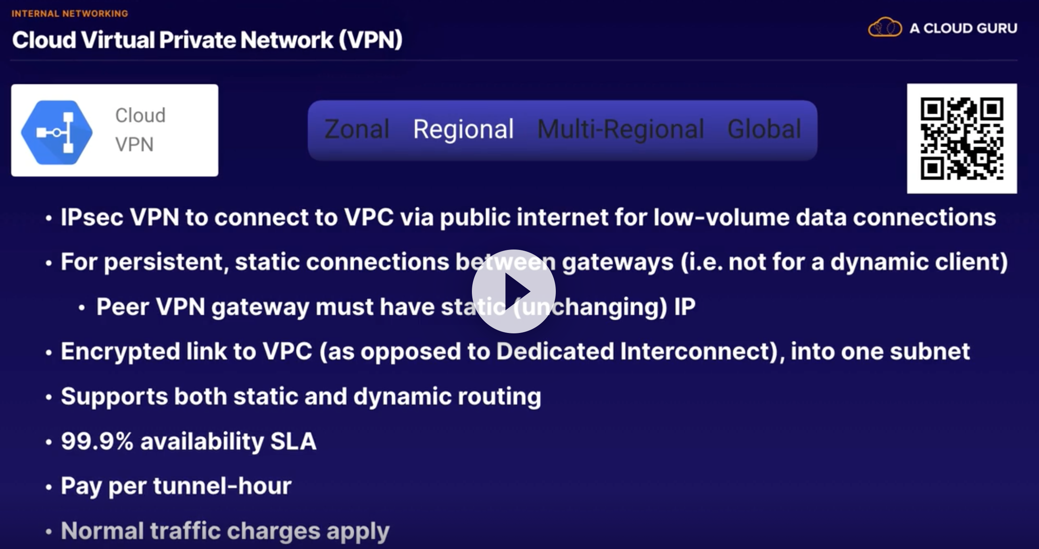

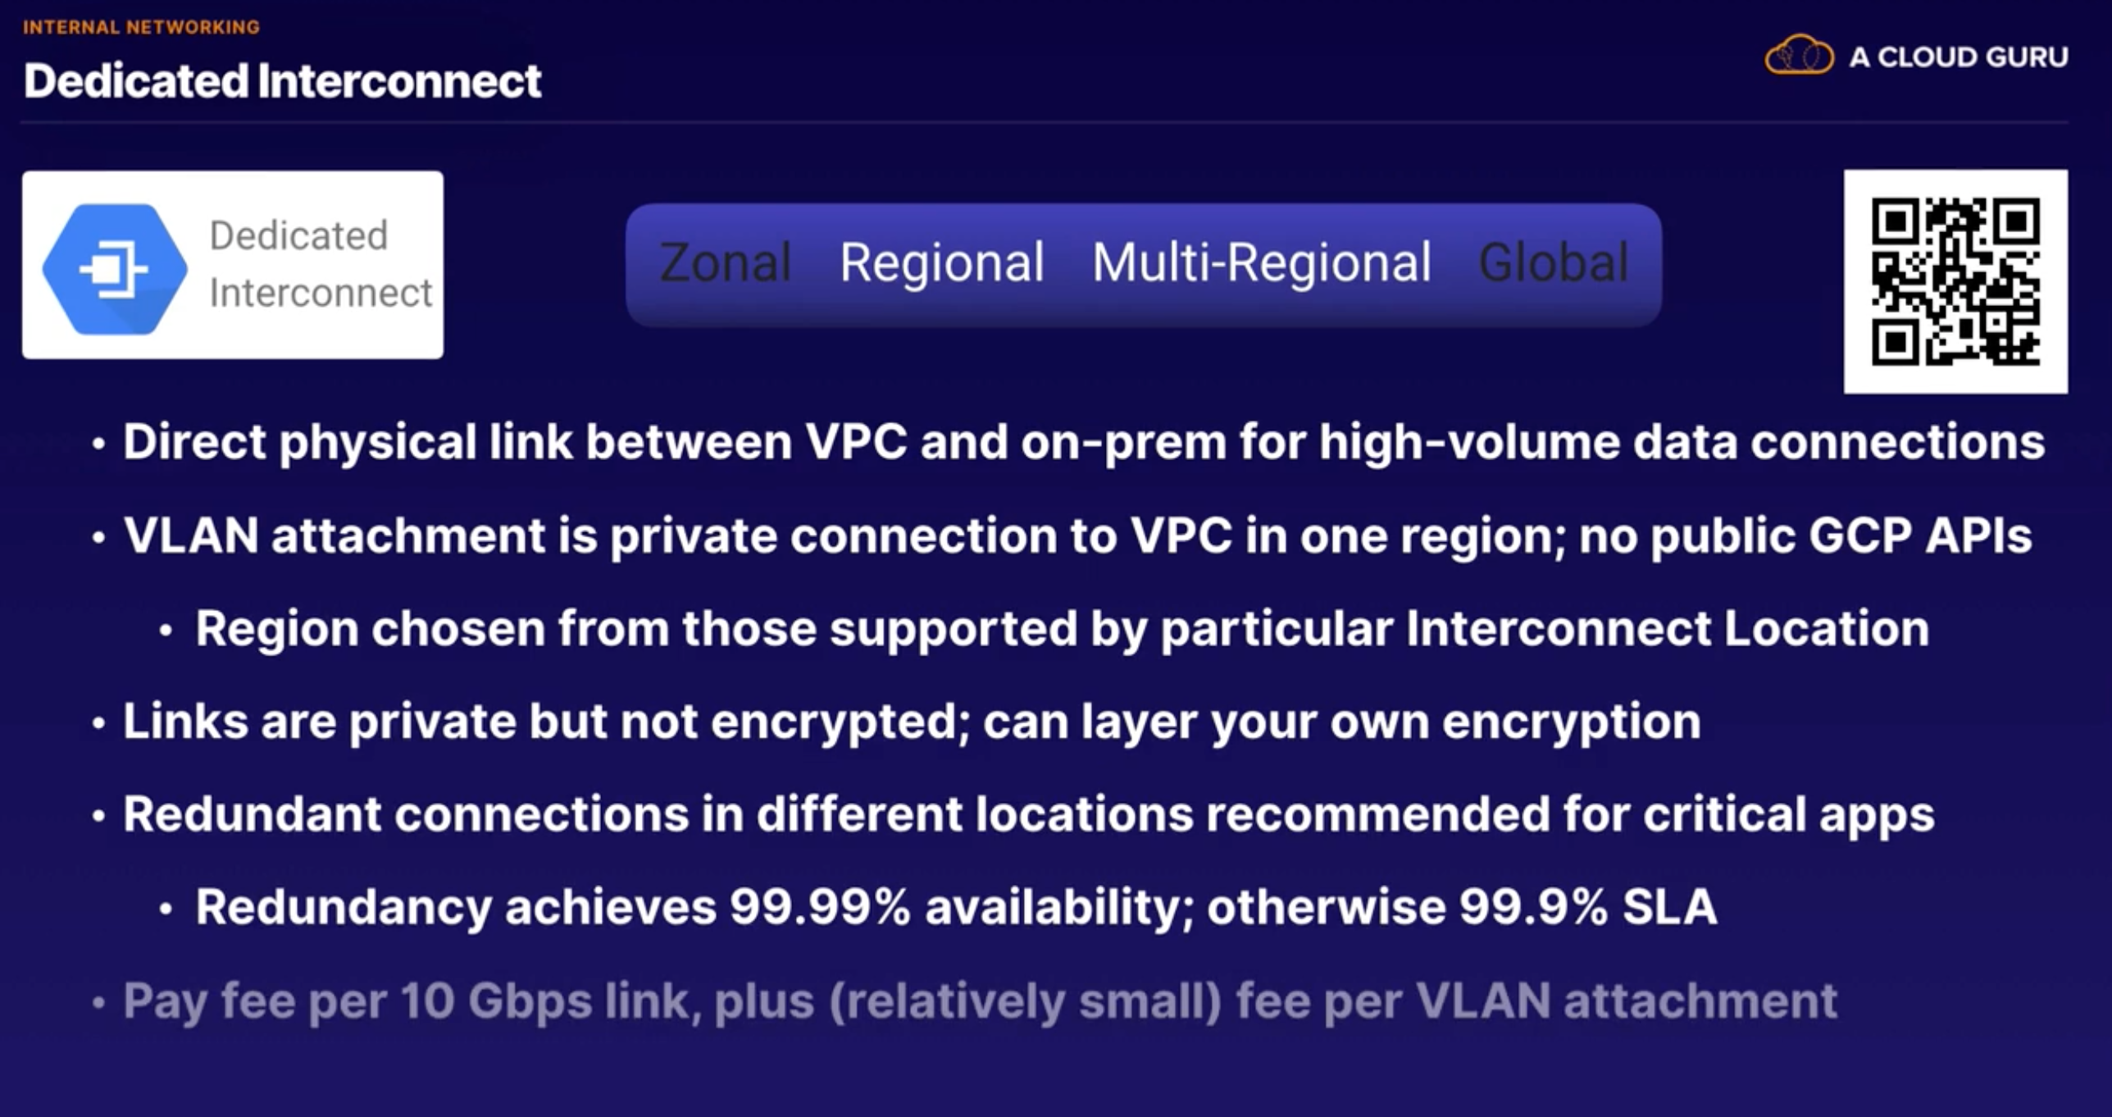

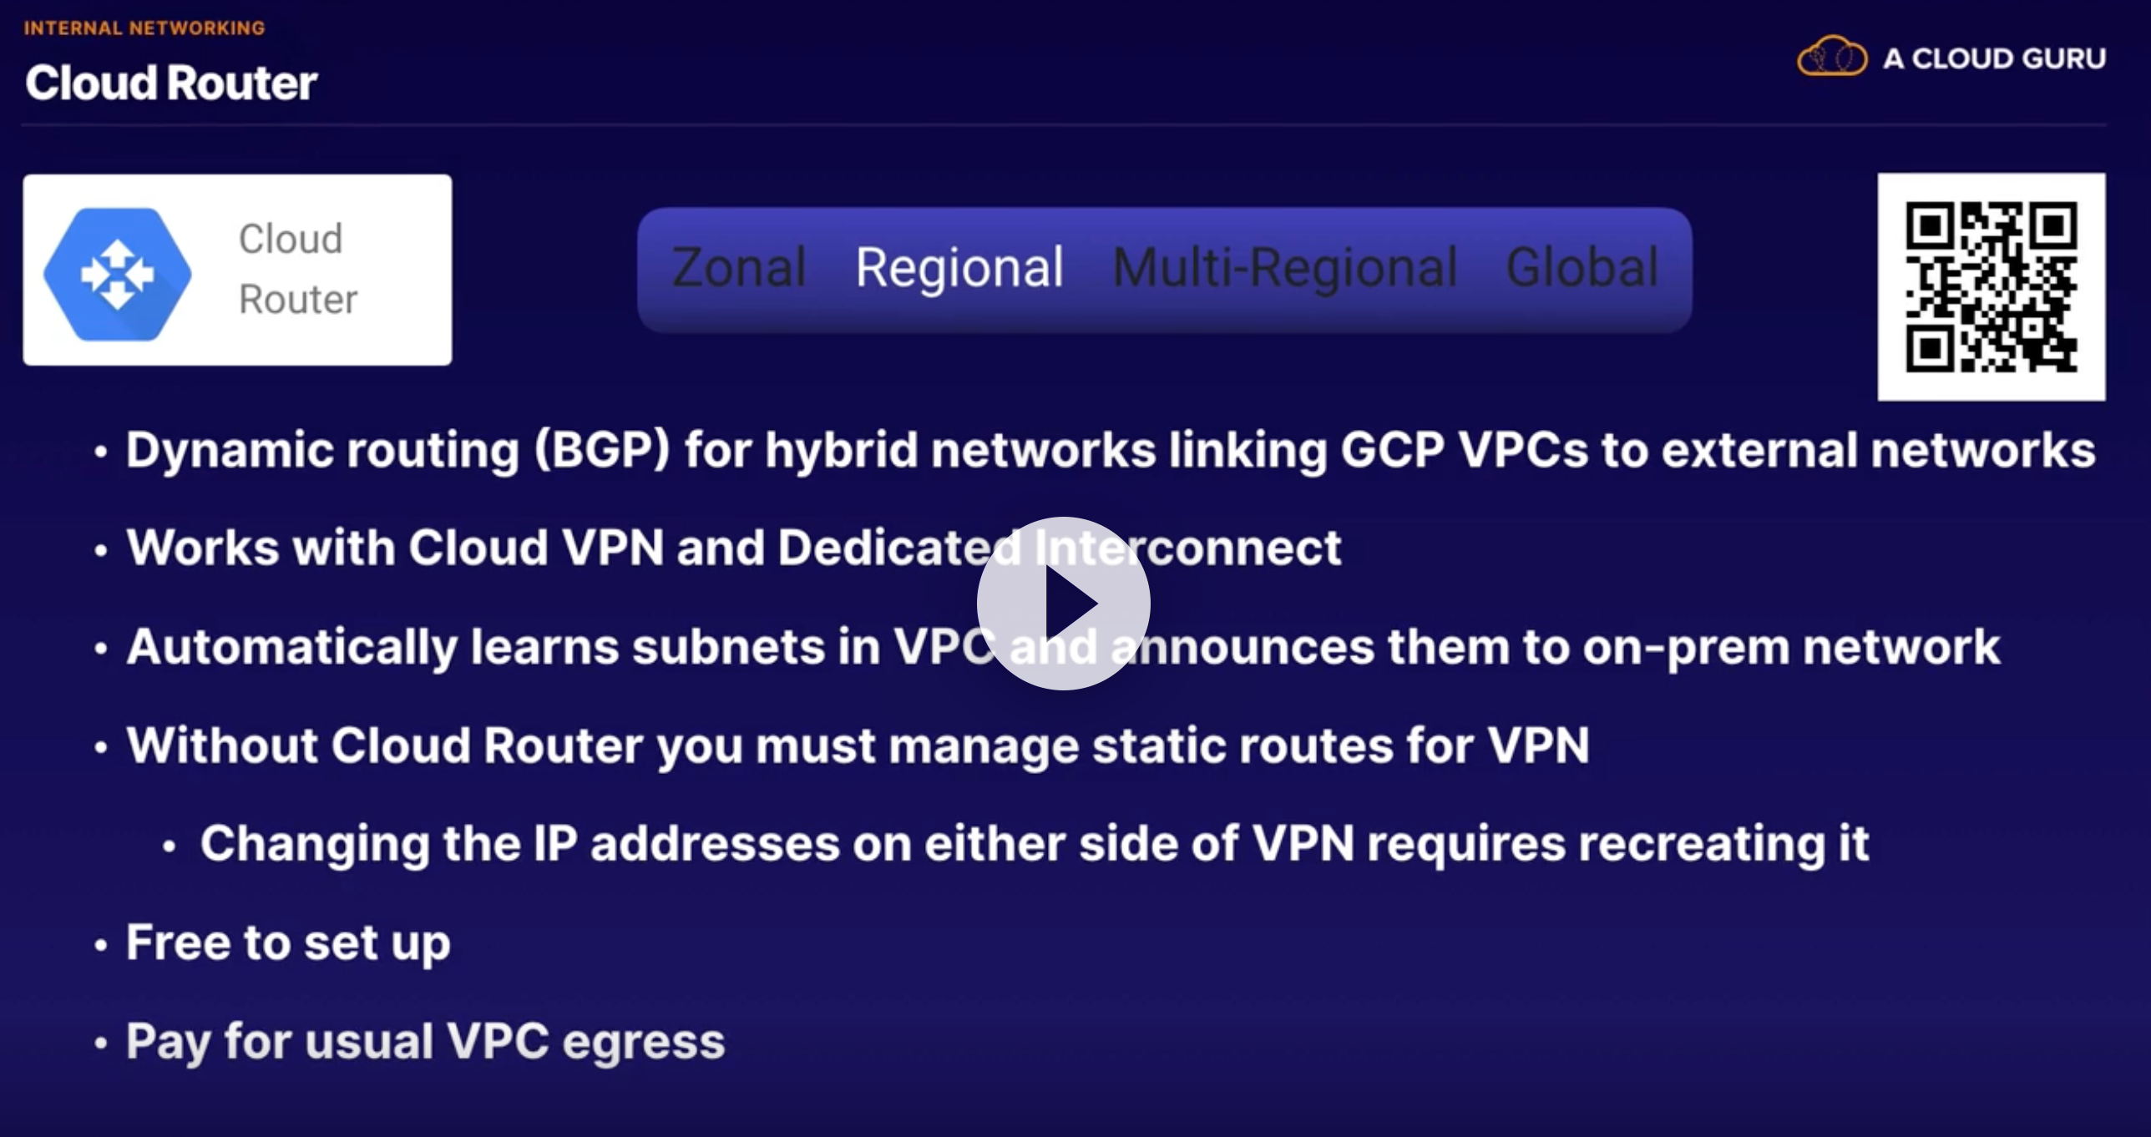

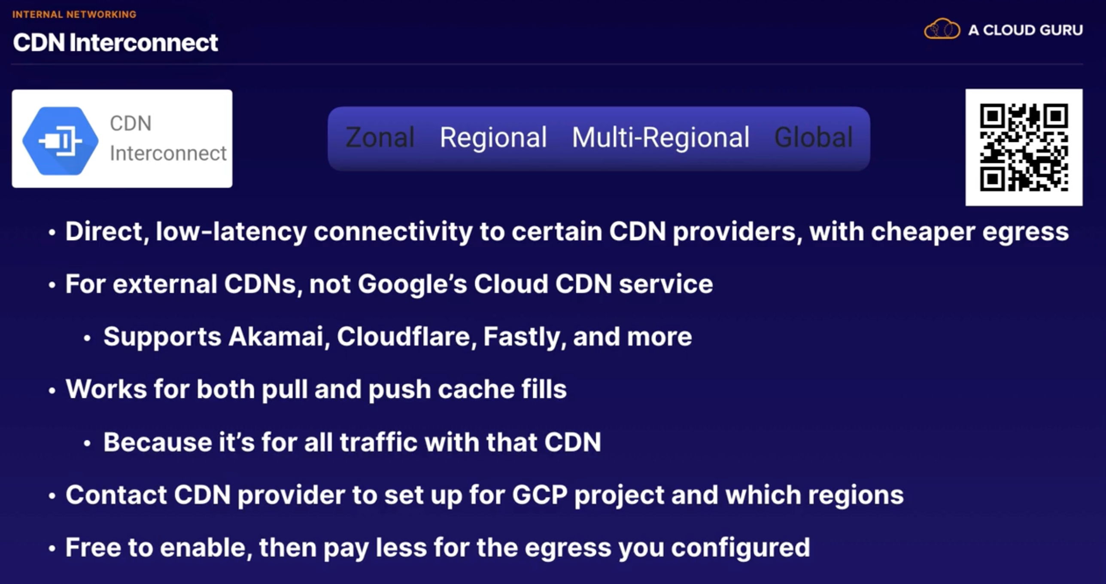

# MAchine Learning and AI

